Experiment 3
Energy and Power Analysis of Signals
OBJECTIVE:
- To calculate the energy and average power of given continuous-time and discrete time signals and classify them as energy signals, power signals, or neither based on their energy and power characteristics.
Experimental Procedure
1. Define the time vector and generate the selected signals.
2. Compute the squared magnitude of each signal.
3. Numerically integrate over a sufficiently large interval for energy.
4. Compute average power over an interval containing several periods for the periodic signal.
5. Compare numerical results with analytical expectations.
6. Classify the signals and record observations.
MATLAB CODE:
% Experiment 3: Energy and Power Analysis
clc; clear; close all;
dt = 0.001;
t = 0:dt:5;
xE = exp(-t);
xP = sin(2*pi*5*t);
E_num = trapz(t,abs(xE).^2);
T0 = 1/5;
idx = t <= 2;
P_num = (1/(t(find(idx,1,'last'))-t(1))) * ...
trapz(t(idx),abs(xP(idx)).^2);
figure;
subplot(2,1,1);
plot(t,xE); grid on;
title('Energy Signal e^{-t}u(t)');
xlabel('Time (s)'); ylabel('Amplitude');
subplot(2,1,2);
plot(t,xP); grid on;
title('Power Signal sin(2pi5t)');
xlabel('Time (s)'); ylabel('Amplitude');
fprintf('Numerical energy = %g\n',E_num);
fprintf('Numerical average power = %g\n',P_num);
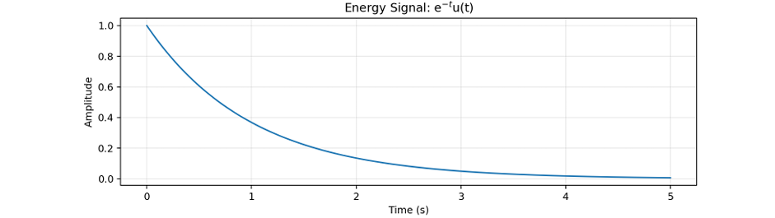
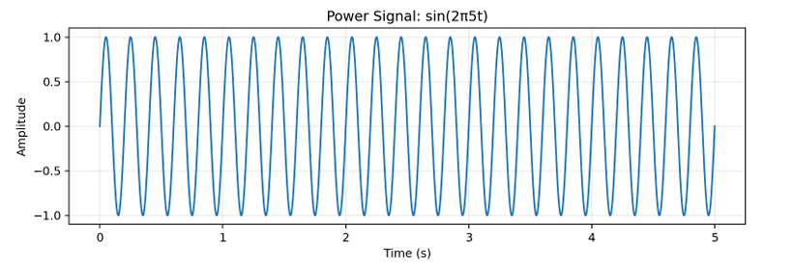

Conclusion
Energy and average power were calculated successfully, and the given signals were classified as energy and power signals based on their energy and power characteristics.

